Pre/Post Deployment Guide for TDLR eInspections



# **Deployment Guide**

*Prepared for TDLR*

*Prepared by:*

**Microsoft**

Contents

**Deployment Guide** 1

1 Introduction 4

1.1 Document Purpose 4

1.2 Environment Information 4

2 Dynamics 365 CE Deployment 5

2.1 Prerequisites 5

2.2 Pre–Deployment Step 5

2.3 CRM Solution Movement 6

2.3.1 Exporting the solutions from Dev 6

2.3.2 Import the solution to UAT/QA/Prod 9

2.4 Post Deployment Activities 15

3 Canvas App Deployment Steps 16

3.1 Export Canvas App 16

3.2 Import Canvas App 17

3.3 Update the Canvas App to the most recent version 20

3.4 Share Canvas App with Security Groups 21

4 One Time Environment Set-up Activities 22

4.1 Setup Environment Security Group 22

4.2 Setup Security Groups in AAD and Corresponding AAD Security Group Teams in eInspections 23

4.3 Import Master Data 23

4.4 Setup Inspection Approver Teams 24

4.5 Update Inspector Users with the correct Region and InspectorID 24

4.6 Turn Auditing on 24

4.7 Update Configuration Table with the Production Settings 24

4.8 Update Field Level Security 24

1. Introduction
   1. Document Purpose

This solution will guide how to move your changes between source and target environment. With the help of this document user can understand what the steps for deployment are, how to configure the solution, Pre, and Post execution steps.

* 1. Environment Information

Please find the environment name below.

|  |  |
| --- | --- |
| Environment Name |  |
| DEV URL | https://orgaa83e46e.crm9.dynamics.com/ |
| TEST URL | https://org8d4c63e3.crm9.dynamics.com/ |
| PROD URL | https://orga556fffe.crm9.dynamics.com/ |

1. Dynamics 365 CE Deployment
   1. Prerequisites

The user who is doing the deployment must have the following.

1. User must have system administrator role in CE.
2. Initial import should be by SVC_INSP_Flow@tdlr.texas.gov
   * + 1. Solutions

Below is the list of solutions. There are two solutions which will be moved sequentially. The first solution contains all the CRM components (Entities, Workflows, web resource, etc.) and the second solution contains only power automate flows.

|  |  |
| --- | --- |
| Solution Name | Version |
| TDLR eInspections ConfigBase  TDLR eInspections Flows | 1.0.0.0  1.0.0.0 |

* 1. Pre–Deployment Step
     + 1. Take a Backup of target System

Please refer to the URL below, this will navigate you to the admin portal for environment back up. Please do take the backup if you are moving the solution in to the production.

[https://make.gov.powerapps.us/](https://make.powerapps.com/)

<https://docs.microsoft.com/en-us/power-platform/admin/backup-restore-environments>

* 1. CRM Solution Movement

The CRM solution will be moved manually.

* + 1. Exporting the solutions from Dev
       1. Steps to export TDLR eInspections ConfigBase

Login to make portal[https://make.gov.powerapps.us/](https://make.powerapps.com/)

1. Click on solutions in the left navigation area
2. Search for the solution “TDLR eInspections ConfigBase” as shown in below screenshot.

1. After locating the above solution click on ellipses (three dots) and click on “export” option to export the solution. On the next screen please make sure you select the solution to be exported as “Managed”. Once the export operation is completed, the solution will be downloaded onto your local computer.

* + - 1. Steps to export TDLR eInspectionsFlows.

1. Login to make portal([https://make.gov.powerapps.us](https://make.powerapps.com))
2. Click on solutions in the left navigation area
3. Search for the solution “TDLR eInspections Flows” as shown in below screenshot.

1. After locating the above solution click on ellipses (three dots) and click on “export” option to export the solution. On the next screen please make sure you select the solution to be exported as “Managed”. Once the export operation is completed, the solution will be downloaded onto your local computer.

* + 1. Import the solution to UAT/QA/Prod
       1. steps to import “TDLR eInspections ConfigBase”.

1. Login to maker portal of UAT (<https://make.gov.powerapps.us> )
2. After login look for solutions in the left navigation area and click on it.
3. Now, look for “Import” option on top ribbon area as shown in below screenshot.

1. Click on “Import” and select the solution from your local computer (which was downloaded during the export steps)

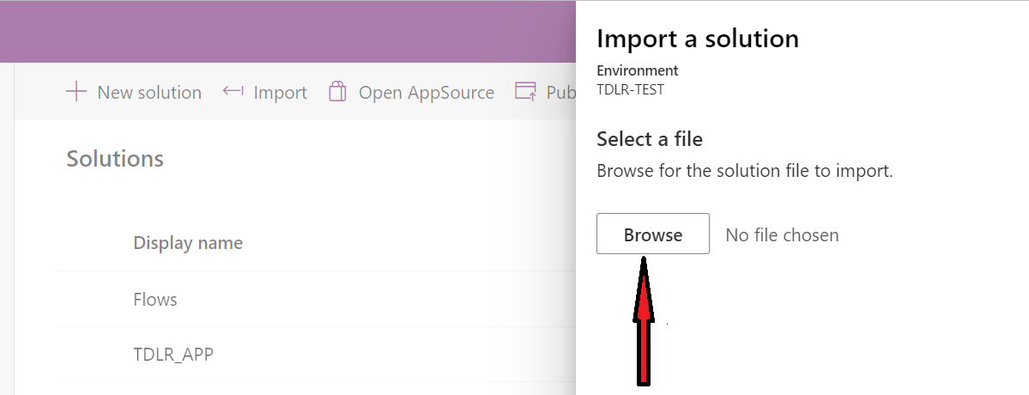

1. After clicking browse and selecting the solution, now click “Next” button appearing at bottom of the screen.

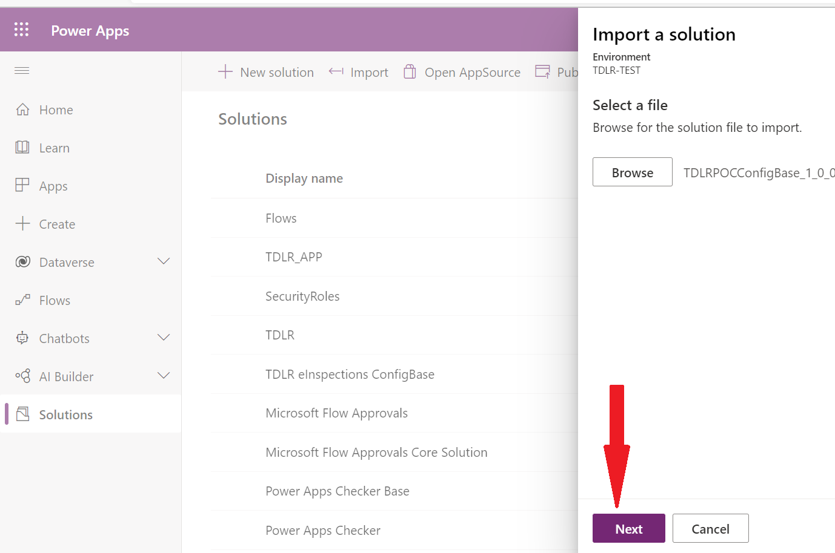

1. On the next screen, scroll down to search for “**Advance settings**”. Expand the “Advance settings” and make sure the below options in the screen shot are selected as it is.

1. After clicking on import option, you will see notification as shown in below screen shot about the solution is getting imported.

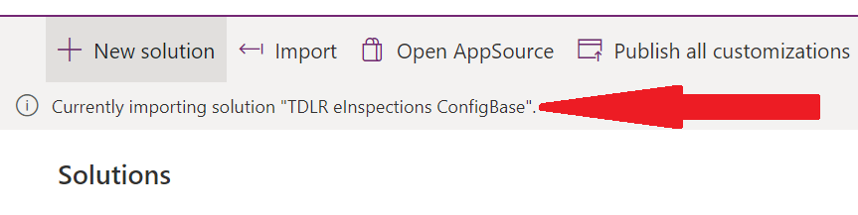

h) Once the solution is imported, click on Publish all customization to see the changes in environment.

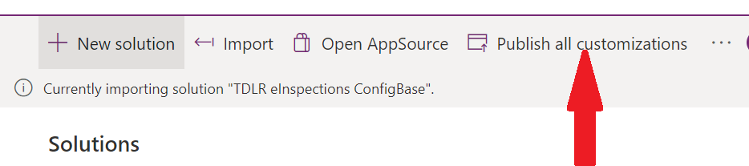

* + - 1. Steps to import TDLR eInspections Flows.

1. Login to maker portal of UAT (<https://make.gov.powerapps.us> )
2. After login look for solutions in the left navigation area and click on it.
3. Now, look for “Import” option on top ribbon area as shown in below screenshot.

1. Click on “Import” and select the solution from your local computer (which was downloaded during the export steps)

1. After clicking browse and selecting the solution, now click “Next” button appearing at bottom of the screen.

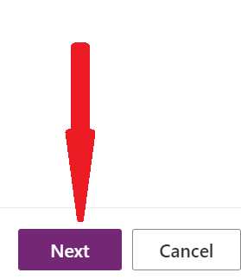

1. On the next screen, scroll down to search for “**Advance settings**”. Expand the “Advance settings” and make sure the below options in the screen shot are selected as it is.

1. After clicking on import option, you will see notification as shown in below screen shot about the solution is getting imported.

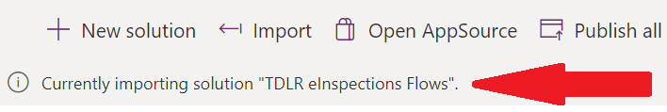

1. Once the solution is imported, click on Publish all customization to see the changes in environment.

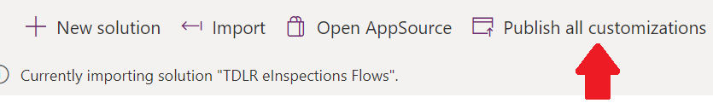

* + - 1. Updating Flow Connections

As part of the initial import of TDLR eInspections Flows Solution new connections need tp be created as below

Note:

1. Email connections should be connected to proofofinspections@tdlr account
2. OneDrive, WordOnline and Office 365 connections should be to SVC_INSP_FLOW
3. HTTP with AzureAD connection should be the current CE Environment : <https://orga556fffe.crm9.dynamics.com/>

* 1. Post Deployment Activities
     + 1. Activate workflows and check owner of the workflow

a) Login to target CRM instance.

b) Go to Solutions.

c) Open the solution that you have just imported.

d) Click on Processes and see if there are any deactivated workflows then activated them.

e) Check the owner of the workflows, it should be a service account or any other but not an individual account.

* + - 1. Activate Cloud flows.

1. Login in to <http://make.gov.powerapps.us/> with service account.
2. Activate all the flows available in the solutionTDLR eInspections Flows**.**
3. Re-activate the flows (turn off & turn on) and ensure all the flows are in turn on state.
4. If connections need to be updated go to **Data>Connections>Switch account** and update the connection

1. Canvas App Deployment Steps
   1. Export Canvas App

1. Select TDLR eInspections Mobile and Export Package

2. Update Name to TDLR eInspections

* 1. Import Canvas App

1. Select Import Canvas App and import from location where export was saved

2. In Action Select Create as New and Save

3. Select Import

* 1. Update the Canvas App to the most recent version

Open Details on the Canvas App

Select Version and select the most recent version then PUBLISH.

* 1. Share Canvas App with Security Groups

1. One Time Environment Set-up Activities
   1. Setup Environment Security Group
2. Setup Environment Security Group in AAD: SG_INSP_PowerApps
3. Update Prod Environment with Security Group

Open Environment > Edit > Save

* 1. Setup Security Groups in AAD and Corresponding AAD Security Group Teams in eInspections

* 1. Import Master Data

Region

County

Configurations

License Type

Program Types

ATU HT Indicators

Requirement Types

Statute Violations

* 1. Setup Inspection Approver Teams

* 1. Update Inspector Users with the correct Region and InspectorID
  2. Turn Auditing on
  3. Update Configuration Table with the Production Settings
  4. Update Field Level Security